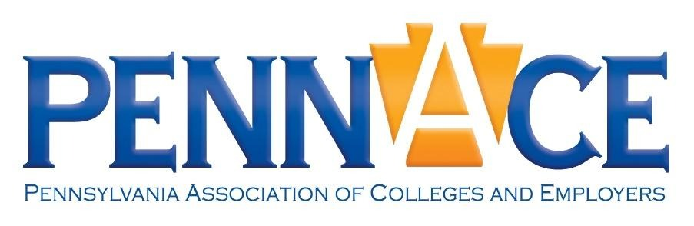
Sponsorship | Exhibitor | Advertisement Packages

Pennsylvania Association of Colleges and Employers Annual Conference:
Purpose, Pathways, and Possibilities – Empowering People for a Changing World of Work

Penn Stater Conference Center, State College, PA | May 19th – 21st, 2026

Sponsorship Packages

Platinum Sponsor - $2,250

- Organization PennACE Honorary* Membership for 4 individuals
- Registration for conference for 2 representatives
- Full-page color ad on back cover of conference programs
- Logo on front page of conference program
- Link to website from PennACE Website
- Table in exhibitor hall for duration of the event
- Thank you announcement during General Session

Gold: Luncheon/Breakfast Sponsor - $1,800

- Organizational PennACE Honorary* Membership for 3 individuals
- Registration for conference for 2 representatives
- Full-page ad in conference program
- Logo on front page of conference program
- Link to website from PennACE website
- Thank you announcement during sponsored meal
- Table in exhibitor hall for duration of event

Silver: Reception Sponsor - $1,200

- Organizational PennACE Honorary* Membership for 2 individuals
- Registration for conference for 1 representative
- ½-page ad in conference program
- Logo on front page of conference program
- Link to website from PennACE Website
- Thank you announcement during reception
- Table in exhibitor area for duration of event

Bronze: Pre-Conference Sponsor - $600

- Organizational PennACE Honorary* Membership for 1 individual
- Registration for conference for 1 representative
- ¼-page ad in conference program
- Name on pre-conference activity/reception and logo on tickets
- Thank you announcement during pre-conference events
- Table in exhibitor area for duration of event

Copper: Conference Breakout Session Room Sponsor - $500

- Organizational PennACE Honorary* Membership for 1 individual
- Registration for conference for 1 representative
- Company name and logo on conference breakout session room door
- Company name listed with associated room in conference schedule
- ¼-page ad in conference program
- Thank you announcement during event
- Table in exhibitor area for duration of event

Exhibitor & Advertising Packages

Exhibitors - $425 ($325 early-bird before 3/31/2026)
- Organization PennACE Honorary* Membership for 1 individual
- Registration for conference for 1 representative for Wednesday only
- ¼-page ad in conference program
- Table in exhibitor area for Wednesday

 | Early Bird (3/31/2026) | Regular
Exhibitor | $325 | $425
Exhibitor Guest | $125/person | $125/person

Advertising - $50-$100

Quarter Page | $50 | Horizontal: 4.25 x 5.5
Half-Page | $75 | Horizontal: 8.5 x 5.5
Full-Page | $100 | Horizontal: 8.5 x 11

*Honorary Membership does not include voting privileges or position on the board

For questions or to express interest in the packages below, please contact:
Joshua Zeigler
PennACE Sponsor/Exhibitor/Advertising Committee
j.zeigler@chatham.edu
