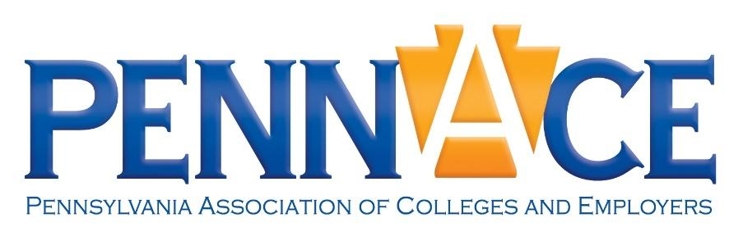
Annual Conference 2026
Schedule
Tuesday, May 19, 2026 - Pre Conference Activities
1:30pm Golf Outing *preregistration required
Glass Fusion Workshop *preregistration required
2:00pm Centre Furnace Mansion Tour *preregistration required
4:00pm University Wine Company Tasting *preregistration required

Wednesday, May 20, 2026
8:30-9:15 Rest & Recharge Session
9:00-10:30 Registration
9:30-10:15 New PennACE Member & First Time Conference Attendees Welcome
10:30-10:45 Welcome
11:00-12:00 Knowledge Session I
Do Hard Things. Leadership Lessons That Can Improve Retention - Based on the
book by Steve Magness, “Do Hard THings. Why We Get Resilience Wrong and
The Real Science of True Toughness”.
More Than a Job Search: Guiding Nontraditional Students (25+) from
Classroom to Career - This presentation will focus on the challenges, barriers,
and expectations of working with students who are nontraditional-aged (25+).
12:00-1:30 Lunch & Networking
1:30-2:30 Express Session I (attend two of the three 25 minute sessions)
Career Cafe - this initiative offers a simple, scalable “menu” of 15-60 minute
partnerships designed to strengthen collaboration between faculty and career
Services
How to Build a Regional Internship Summit *PennACE Grant Recipient - Learn
how a few PennACE members partnered to create the Berks Internship Summit,
a half-day, employer-focused event supporting regional workforce development
and student retention.
The Prepared Freshman: What Early Career Counseling Could Mean for
Colleges and Employers - There are more and more high schools enhancing
their ability to provide career counseling for their students. In this session you
will learn about what this trend could mean for colleges and employers.
2:45-3:45 Knowledge Session II
Pairing Personality with Professionalism: Turning Type into Trajectory - This
interactive session equips career and professional development practitioners
and employers with a proven, campus-tested model for delivering engaging 16
Personalities/MBTI based workshops.
From Vision to Buy-In: A Replicable Strategic Planning Model for Career
Services Leaders - This session shares an accessible, replicable approach to
strategic planning in career services that aligns student outcomes and impact
with institutional priorities and advancement goals.
Small Behaviors, Big Impact: How Everyday Habits Shape Career Readiness and
Professional Success - Drawing inspiration from behavior-change research
popularized in Atomic Habits, this session explores how everyday habits - many
of them nonverbal - signal professionalism, readiness, and leadership potential.
3:45-4:00 Afternoon Snack Break ?
4:15-5:15 Knowledge Session III
Let’s Talk: Boosting Your First Destination Survey: Tools, Tactics, and Takeaways
This session will discuss effective approaches for improving first destination
reporting. Participants will have the opportunity to ask questions and share their
processes.
From Overwhelmed to Integrated: A Practical Strategy for the AI Anxious - This
session offers a grounded starting point for those who feel fatigued by AI.
Developing World Ready Graduates through Cross Campus Collaboration to
Integrate the NACE Career REadiness Competencies
This presentation will provide an overview of the the efforts by faculty and
colleagues across Duquesne University’s campus to integrate the NACE Career
Readiness Competencies, the partnership that led to this initiative, and the
process for developing the collaborative approach that led to its success.
5:15-6:30 PennACE Gameshow & Happy Hour
6:45 Group Dinners or Dinner on your own

Thursday, May 21, 2026
9:00-10:00 Express Session II
Mindfullness, Coloring and Zentangles - This hands-on workshop will help
participants discover ways to relax and de-stress.
Staying True to You: Authenticity, Creativity, and Career Development - This
session explores how authenticity and creativity play a critical role in meaningful
career development, particularly for students and early-career professionals.
Supply Programs vs. Demand Programs. Curb Your Student Attendance Anxiety SRU will share their “litmus tests” surrounding producing events that shore up
student attendance, revenues and effectiveness.
10:00-11:30 Brunch & General Meeting
11:40-12:40 General Session - Growth Mindset in a Changing World of Work: Purpose, Pathways,
and Possibilities in Practice
This interactive session explores growth mindset as a practical framework for
empowering students, candidates, and early-career professionals to thrive amid
uncertainty.
12:45-1:15 Closing Session & Prizes

